JMIS-Journal Paper Template (Font size: 18)

Author: First Author¹,Second Author^{2*} (Font: Times New Roman, Font size: 12)

Abstract(Font: Times New Roman, Font size: 14)
(Times New Roman, font size: 9)
This document shows the required format and appearance of a manuscript prepared for JMIS journal. Begin the abstract 16 points below the author names, with the word “Abstract” in bold followed by a period. The abstract should consist of a single paragraph containing no more than 300 words. It should be a summary of the paper and not an introduction. Because the abstract may be used in abstracting and indexing databases, it should be self-contained (i.e., no numerical references) and substantive in nature, presenting concisely the objectives, methodology used, results obtained, and their significance. A list of up to four keywords should immediately follow, with the keywords separated by commas and ending with a period. The text should be single-spaced and fully justified throughout the manuscript.
Key Words: About Four key words or phrases in alphabetical order, separated by commas.

I. INTRODUCTION
(Times New Roman, Font size: 10)

This document provides instructions for style and layout, information on installing the Word template and how to submit the final version. The instructions are designed for the preparation of a camera-ready and accepted paper in MS Word and should be read carefully.
Manuscript received April 24, 2019; Accepted May 09, 2019. (ID No. JMIS-19M-04-013)
Corresponding Author (*): Name, Address, Tel, E-mail.
¹Department, University, Region, Country, E-mail
²Company, Region, Country, E-mail
Prepare your paper in the same style as used in this sample document. These instructions also contain the necessary information for manual editing. Authors should realize that once the accepted paper is submitted for publication in the journal, the print and online version will be almost identical to the paper submitted for publication, except for the pagination, volume, and copyright year information.
A cover of each paper manuscript should include a title, authors’ names (main author and co-authors), author’s organizations, contact information (email
address), and the author’s area of expertise. The first page of a main text should only contain title, abstract with a length of about 200 words, and key-words with around four words.
The title of each paper is expected to cover the whole contents of the paper and it should as concise as possible.

II. GUIDELINES FOR MANUSCRIPT PREPARATION

Manuscripts must be written in English. Authors whose native language is not English are recommended to seek the advice of a native English speaker, if possible, before submitting their manuscripts. The pages in the manuscript should not be numbered and in the text no reference should be made to page numbers; if necessary, one may refer to sections. Try to avoid excessive use of italics and bold face.
Each paper should be written in A4 and be submitted in MS-Word format (use the JMIS’ template). The paper should also be written within 12 pages (with a two-column format) including figures, charts, and tables.
The numbers corresponding to chapters in the paper should be written in Roman numerals (I, II, III, IV...) and the numbers corresponding to sections should be written in Arabic numerals (1, 2, 3, 4...).
High resolution figures are required in this Journal. Directly drawing diagrams in the manuscript is not acceptable.
The numbers corresponding to chapters in the paper should be written in Roman numerals (I, II, III, IV...) and the numbers corresponding to sections should be written in Arabic numerals (1, 2, 3, 4...).

2.1. Abbreviations and Acronyms
2.1.1. Boldface, italicized, lowercase paragraph heading
Define abbreviations and acronyms the first time they are used in the text, even after they have already been defined in the abstract. Abbreviations such as JMIS, SI, ac, and dc do not have to be defined. Abbreviations that incorporate periods should not have spaces: write “C.N.R.S.,” not “C. N. R. S.” Do not use abbreviations in the title unless they are unavoidable (for example, “JMIS” in the title of this article)
All tables should be numbered consecutively with Arabic numerals. They should be referred to in the text and should be numbered according to their order of mention in the text. In addition, all tables should, not only list all abbreviations in the table in footnotes at the end, but also have a title that is concise and describes the table’s contents. Vertical lines are not used. The table should be self-explanatory and supplement, not duplicate, the text. If the table or any data therein have been published, a footnote to the table must give permission information to the original source. The structure should be clear, with simple column headings giving all units. A table should not exceed one page when printed. Use lowercase letters in superscripts ^{a,b,c...} for special remarks.

2.2. Figures and Tables

All figures should be of high quality meeting with the publishing requirement with legible symbols and legends. In preparing the figures, authors should consider a size reduction during the printing process to have acceptable line clarity and character sizes. Use only figures that are necessary to illustrate the meaning of the text. Figures must be black and white of high contrast. All figures should be referred to in the text as, for example, Fig. 1, Fig. 2(a), or Figs. 1-3.

2.3. Typographical style and layout
2.3.1. Type area
Always select A4 as the paper size in the document settings. The type area is 16.2 cm wide and 21.5 cm long. This area must be used to the maximum, and at the same time must not be exceeded. The following margin settings for A4 size paper will produce the correct result: top 4.5 cm; bottom: 3.7 cm; left and right: 2.4 cm.

2.3.2. Font
The font type for running text (body text) is 10 point Times New Roman. For literal text, please use one of the sans-serif fonts, or Courier. Use roman as default style, and keep bold and italics for section headings, subsection-headings, author’s affiliations, and special emphasis. Font sizes and styles are indicated in Table 1. In order to get the correct font size and spacing, use the template styles as much as possible to format your text.

Table 1. Font sizes and styles.
Style name | Brief Description
Article Title | 16 pt, bold
Author Names | 12 pt, bold
Author Affiliations | 10 pt
Abstract | 9 pt
Keywords | 9 pt
Chapter | 12 PT, BOLD
HEADING 1 | 10 PT, BOLD
Heading 2 | 10 pt, bold
Heading 3 | 10 pt, italic
Paragraph | 10 pt
Figure caption | 9 pt
Table caption | 9 pt

2.3.3. General layout
Use single line spacing throughout the document. Keep the abstract, running text and long captions justified; the chapter title, author’s name, affiliation, the table text, section headings – aligned left. Indent the first line of each paragraph by 0.37 cm.

2.3.4. Title page
Use sentence case for the title. Do not use capitals for author’s surname. Add “and” before the last au-thor. Do not add a period after the last keyword.

2.3.5. (Sub-) section headings
Apply the styles defined in Table 1 to the headings. Use sentence case in the headings. Whether or not you use automatic numbering, please check it care-fully. Keep headings flushed left. Headings should not have a full stop at the end.

2.3.6. Footnotes and endnotes
Footnotes should only be used if absolutely essential. In most cases it is possible to incorporate the information in the text. If used, they should be numbered in the text, indicated by superscript numbers and kept as short as possible. If they take up more space than roughly 10% of the type area, list them as endnotes, before the References. Footnotes and end-notes should both be numbered in arabic numerals and, in the case of endnotes, preceded by the heading “Endnotes”.

2.3.7. Equations
When you use some equations, all equations should be editable with MS equation editors or MikTex editor. All equations should be aligned with the center and the number of equations should be aligned with the left of two spaces margin as the following:

$θ=\tan^{-1}\left(\frac{y_{nc}-y_{sc}}{x_{nc}-x_{sc}}\right).$ (1)
Also, set the margin to one line from the given equation and you should give “,” or “.” as one sentence.

2.3.8. Figures
2.3.8.1. General remarks on figures
The text should include references to all figures. Refer to figures in the text as Figure 1, Figure 2, etc., not with the section number included, e.g. Table 3.2, Figure 2.3, etc. Do not use the words “below” or “above” when referring to the tables, figures, etc.
Do not collect figures at the back of your article but incorporate them in the text. Position tables and figures at the top or bottom of a page, with at least 2 lines extra space between tables or figures and the running text. Illustrations should be centered on the page, except for small figures that can fit side by side inside the type area. Tables and figures should not have text wrapped alongside.
Each figure should have a self-explanatory caption. Place the figure captions below the figure. Abbreviate ‘Figure’ to ‘Fig.’ to start the caption and use roman font for the text of the caption. Keep table and figure captions justified. Center short figure captions only. The minimum font size for characters in tables is 8 points, and for lettering in other illustrations, 6 points.
On maps and other figures where a scale is needed, use bar scales rather than numerical ones of the type 1:10,000.

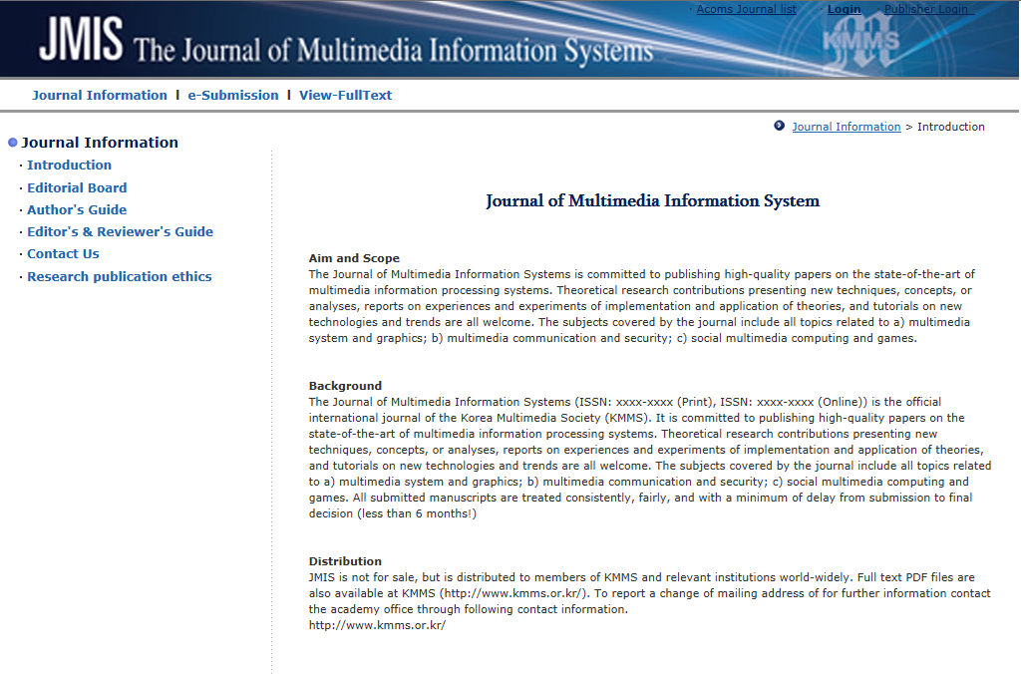
Fig. 1. Homepage of JMIS. (Font size: 9)

III. CONCLUSION

When citing any paper published in JMIS, it should be indicated the name of the journal as Journal of Multimedia and Information Systems.
The publishing charge for general publishing is 100,000 won (USD 100) for an accepted paper (up to 10 A4 pages). Furthermore, the JMIS charges extra 100,000 won (USD 100) for the paper acknowledging a financial support from an institution, in addition to the mentioned publication charge in the above.

Acknowledgement
Authors are requested to identify financial support, if any used in the execution of the research and preparation of the article. Those individuals and companies who provided help during the research could also be addressed here.
REFERENCES
Please give as much information as possible [all authors, title, publication/book/conference name, vol. and issue (if relevant), page numbers, etc.]. All references must be referred to within the text (in numerical order).
References to the literature should be mentioned in the main text by arabic numerals in square brackets. All publications cited in the text should be presented in a list of references following the text of the manuscript. References should be listed alphabetically in the style presented in the References section of these instructions. Reference number [3] can be mentioned in the text before reference [1]. Multiple reference can be indicated as [3-5,9].
To produce the reference list at the end of the arti-cle, type the reference number in square brackets, insert a tab and type the text. Use a hard return at the end of each reference only. When the references are complete, select them all, and apply the style References from the template. For manual editing choose Format/Paragraph, and from the Indentation Special menu select: left 0.5 cm, hanging 0.25 cm, tab stop position 0.75 cm. Click OK.

1. Reference examples

Books
[1] F. Giannini and G. Leuzzi, Nonlinear Microwave Circuit Design. NewYork, NY: John Wiley & Sons Inc., 2004.
Journals
[2] H. Ahn and B. Kim, "Equivalent transmission-line sections for very high impedances and their application to branch-line hybrids with very weak coupling power," Journal of Electromagnetic Engineering and Science, vol. 9, no. 2, pp. 85-97, Jun. 2009.
Report
[3] E. E. Reber, R. L. Michell, and C. J. Carter, "Oxygen absorption in the earth’s atmosphere," Aerospace Corp., Los Angeles, CA, Tech. Rep. TR-0200 (4230-46)-3, Nov. Mar. 1988.
Conference Proceedings
[4] S. P. Bingulac, "On the compatibility of adaptive controllers," in Proceedings of the 4th Annual Allerton Conference on Circuit and System Theory, NewYork, Dec. 1994, pp. 8-16.
Papers Presented at Conferences
[5] J. G. Kreifeldt, "An analysis of surface-detected EMG as an amplitude-modulated noise," presented at the 8th International Conference on Medical and Biological Engineering, Chicago, IL, Jun. 1969.
[6] J. Arrillaga and B. Giessner, "Limitation of short-circuit levels by means of HVDC links," presented at the IEEE Summer Power Meeting, Los Angeles, CA, Jul. 1990.
Theses (M.S.) and Dissertations (Ph.D.)
[7] N. Kawasaki, "Parametric study of thermal and chemical nonequilibrium nozzle flow," M.S. thesis, Department of Electronic Engineering, Osaka University, Osaka, Japan, 1993.
[8] J. O. Williams, "Narrow-band analyzer," Ph.D. dissertation, Department of Electronic Engineering, Harvard University, Cambridge, MA, 1993.

Standards
[9] IEEE Criteria for Class IE Electric Systems, IEEE Standard 308, 1969.
Online Sources
[10] R. Bartle, "Early MUD History," 1990. http://www.ludd.luth.se/aber/mud-history.html.
[11] International Survey Highlight Great Public Desire to Seek Early Diagnosis of Alzheimer's, http://www.hsph.havard.edu/news/pressrelease/alzheimers-international-survey, 2013.

Authors
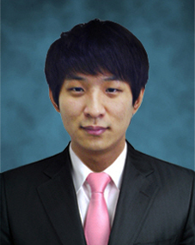
Gwang-Soo Hong received his BS and MS degrees in the Department of Computer Engineering from SunMoon University, Korea, in 2011 and 2013, respectively. In 2013, he joined the Department of Computer Engineering for pursuing his PhD degree at SunMoon University.
His research interests include image coding algorithms, video coding technique and depth estimation algorithms in stereo vision.

Byung-Gyu Kim has received his BS degree from Pusan National University, Korea, in 1996 and an MS degree from Korea Advanced Institute of Science and Technology (KAIST) in 1998. In 2004, he received a PhD degree in the Department of Electrical Engineering and Computer Science from Korea Advanced Institute of Science and Technology (KAIST). In March 2004, he joined in the real-time multimedia research team at the Electronics and Telecommunications Research Institute (ETRI), Korea where he was a senior researcher. In ETRI, he developed so many real-time video signal processing algorithms and patents and received the Best Paper Award in 2007.
From February 2009 to February 2016, he was associate professor in the Division of Computer Science and Engineering at SunMoon University, Korea. In March 2016, he joined the Department of Information Technology (IT) Engineering at Sookmyung Women’s University, Korea where he is currently an associate professor.
In 2007, he served as an editorial board member of the International Journal of Soft Computing, Recent Patents on Signal Processing, Research Journal of Information Technology, Journal of Convergence Information Technology, and Journal of Engineering and Applied Sciences. Also, he is serving as an associate editor of Circuits, Systems and Signal Processing (Springer), The Journal of Supercomputing (Springer), The Journal of Real-Time Image Processing (Springer), Helyion Journal (Elsevier), and International Journal of Image Processing and Visual Communication (IJIPVC). From 2018, he is serving as the Editor-in-Chief (EiC) of the Journal of Multimedia Information System. He also served as Organizing Committee of CSIP 2011 and Program Committee Members of many international conferences. He has received the Special Merit Award for Outstanding Paper from the IEEE Consumer Electronics Society, at IEEE ICCE 2012, Certification Appreciation Award from the SPIE Optical Engineering in 2013, and the Best Academic Award from the CIS in 2014. He has been honored as an IEEE Senior member in 2015.
He has published over 200 international journal and conference papers, patents in his field. His research interests include software-based image and video object segmentation for the content-based image coding, video coding techniques, 3D video signal processing, wireless multimedia sensor network, embedded multimedia communication, and intelligent information system for image signal processing. He is a senior member of IEEE and a professional member of ACM, and IEICE.

